Influential Node Analysis on City Networks

# Problem Statement

Global economy is highly driven by the business ties between cities and identifying the importance of each city on global scale is a difficult problem. There exist many methods to identify a set of nodes in a network, but changing dynamics of cities make it difficult to select a particular method.

# Objective

To discover a set of influential cities which have high potential on global economy.

# Study Design

## Data set

This study analyzes a set of weighted, undirected graphs of 1487 cities of 189 countries from years 2010, 2013, 2016 and 2019. Each vertex represents a city, while an edge between two cities represents business ties between them. The weight on each edge is the number of business ties. Where a business tie means a business has two branches in two cities. An edge between two cities, carrying weight of 2 means there exist two business which have their physical presence in both cities.

#### Network statistics

|  |  |  |  |  |
| --- | --- | --- | --- | --- |
| Metric | 2010 | 2013 | 2016 | 2019 |
| vertices | 1209 | 1358 | 1405 | 1422 |
| edges | 39904 | 49926 | 62523 | 68668 |
| average\_degree[[1]](#footnote-1) | 66.012 | 73.529 | 89.001 | 96.579 |
| average\_path\_length[[2]](#footnote-2) | 2.287 | 2.268 | 2.264 | 2.244 |
| highest\_degree[[3]](#footnote-3) | 1045 | 1154 | 1188 | 1258 |
| density[[4]](#footnote-4) | 0.055 | 0.054 | 0.063 | 0.068 |
| transitivity[[5]](#footnote-5) | 0.343 | 0.349 | 0.380 | 0.393 |
| assortativity[[6]](#footnote-6) | -0.241 | -0.251 | -0.222 | -0.206 |
| power\_law[[7]](#footnote-7) | 2.095 | 6.122 | 2.210 | 5.929 |

#### Key notes

1. Density is around 5-6%, meaning there exist 1 out of 19 possible connections.
2. Transitivity stays above 0.3, meaning the networks are clustered, like communities in social networks.
3. Assortativity is negative, therefore the networks are not assortative (like social networks), but rather dissortative (like the Internet). Note that assortative networks are more resilient to attacks.
4. Power law coefficient does not stay consistent. In 2010 and 2016, this value is comparable with social networks, but not for 2013 and 2019. It is important to note that using power-law to study scale free structure of networks has been questioned by researchers (cite *The Anatomy of the Facebook Social Graph*, Johan Ugander AND *Power-law distributions in empirical data*, Aaron Clauset). The power-law plots illustrates fat tail, proving the scale-free structure of networks.

## Degree Distribution

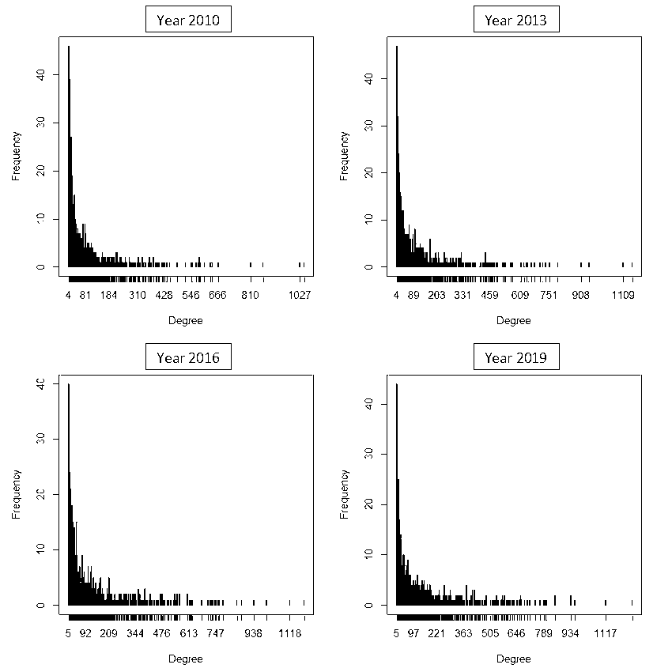

## Power Law Fit

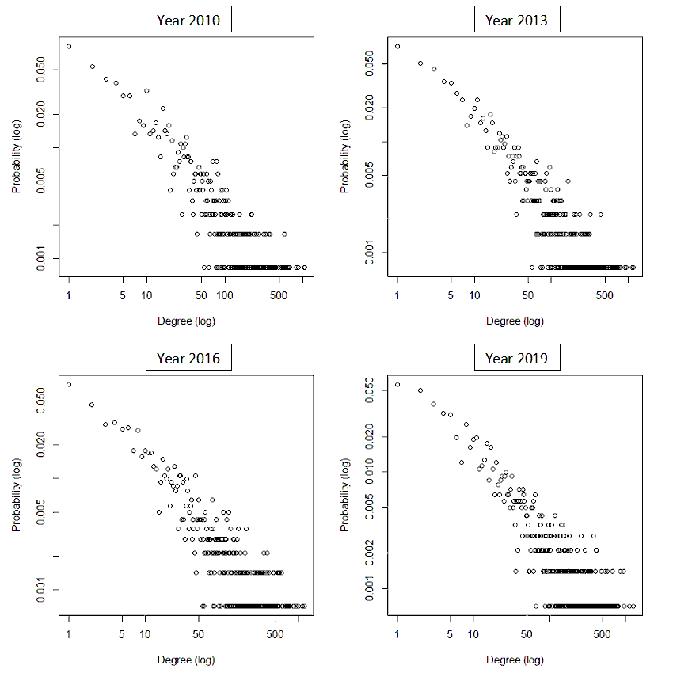

## Influence Mining Methods

1. Centrality measures:
   1. Degree
   2. Betweenness
   3. Closeness
   4. Eigenvector
   5. Eccentricity
2. Heuristics:
   1. Coreness
   2. Pagerank
   3. Collective Influence score
3. Adaptive variants of all centrality measures and heuristics

## Influence Test Methods

1. Resilience test
2. Influence test under Linear Threshold model
3. Influence test under Independent Cascade model

## Experiments and Observations

### Performance of Methods

The influence of 5% most influential nodes extracted

|  |  |  |  |  |  |  |  |  |  |  |  |  |  |  |  |
| --- | --- | --- | --- | --- | --- | --- | --- | --- | --- | --- | --- | --- | --- | --- | --- |
| **year** | **test\_method** | **degree** | **betweenness** | **closeness** | **eigenvector** | **pagerank** | **coreness** | **ci** | **a\_degree** | **a\_betweenness** | **a\_closeness** | **a\_eigenvector** | **a\_pagerank** | **a\_coreness** | **a\_ci** |
| 2010 | RESILIENCE | 137 | 187 | 139 | 135 | 121 | 162 | 98 | 137 | 163 | 139 | 131 | 108 | 160 | 112 |
| 2010 | INFLUENCE\_IC | 594 | 672 | 617 | 562 | 539 | 644 | 580 | 612 | 634 | 619 | 557 | 525 | 630 | 570 |
| 2010 | INFLUENCE\_LT | 517 | 516 | 524 | 512 | 309 | 544 | 133 | 517 | 533 | 519 | 499 | 139 | 540 | 270 |
| **2010** | **HAR\_MEAN** | **275** | **342** | **280** | **269** | **225** | **314** | **154** | **276** | **313** | **279** | **262** | **163** | **310** | **209** |
| 2013 | RESILIENCE | 162 | 208 | 165 | 150 | 136 | 182 | 109 | 156 | 184 | 163 | 152 | 115 | 182 | 130 |
| 2013 | INFLUENCE\_IC | 702 | 745 | 707 | 682 | 627 | 766 | 631 | 716 | 711 | 697 | 733 | 608 | 774 | 684 |
| 2013 | INFLUENCE\_LT | 532 | 562 | 551 | 481 | 273 | 576 | 159 | 536 | 590 | 539 | 486 | 145 | 587 | 265 |
| **2013** | **HAR\_MEAN** | **317** | **378** | **323** | **294** | **238** | **351** | **176** | **310** | **351** | **318** | **300** | **174** | **353** | **232** |
| 2016 | RESILIENCE | 140 | 186 | 144 | 124 | 112 | 156 | 110 | 140 | 161 | 144 | 121 | 112 | 158 | 116 |
| 2016 | INFLUENCE\_IC | 749 | 818 | 778 | 742 | 646 | 778 | 698 | 800 | 768 | 783 | 722 | 628 | 791 | 667 |
| 2016 | INFLUENCE\_LT | 424 | 503 | 449 | 352 | 123 | 476 | 105 | 424 | 514 | 437 | 349 | 98 | 493 | 157 |
| **2016** | **HAR\_MEAN** | **277** | **349** | **287** | **245** | **161** | **306** | **150** | **279** | **317** | **285** | **240** | **145** | **312** | **182** |
| 2019 | RESILIENCE | 125 | 181 | 129 | 106 | 108 | 137 | 98 | 128 | 148 | 124 | 110 | 96 | 139 | 104 |
| 2019 | INFLUENCE\_IC | 776 | 832 | 793 | 760 | 687 | 775 | 684 | 755 | 805 | 775 | 758 | 642 | 813 | 726 |
| 2019 | INFLUENCE\_LT | 395 | 479 | 410 | 313 | 142 | 442 | 88 | 392 | 472 | 405 | 324 | 81 | 452 | 123 |
| **2019** | **HAR\_MEAN** | **254** | **340** | **262** | **215** | **169** | **276** | **130** | **257** | **297** | **254** | **222** | **123** | **282** | **157** |

**Observations:**

1. Betweenness centrality measure stands out on top 8 out of 12 times.
2. Adaptive betweenness follows with a score of 2 out of 12.
3. The other measures to follow are Coreness and Adaptive coreness.
4. Adaptive Pagerank is the worst performer, followed by CI.

### Node commonality (average)

|  |  |  |  |  |  |  |  |  |  |  |  |  |  |  |
| --- | --- | --- | --- | --- | --- | --- | --- | --- | --- | --- | --- | --- | --- | --- |
|  | **deg** | **btwn** | **close** | **eigenv** | **core** | **pgrnk** | **ci** | **a\_deg** | **a\_btwn** | **a\_close** | **a\_eigenv** | **a\_core** | **a\_pgrnk** | **a\_ci** |
| **deg** | 1.00 | 0.62 | 0.91 | 0.83 | 0.47 | 0.86 | 0.42 | 0.99 | 0.75 | 0.90 | 0.86 | 0.33 | 0.85 | 0.69 |
| **btwn** | 0.62 | 1.00 | 0.65 | 0.55 | 0.34 | 0.73 | 0.35 | 0.63 | 0.78 | 0.65 | 0.55 | 0.27 | 0.73 | 0.53 |
| **close** | 0.91 | 0.65 | 1.00 | 0.76 | 0.48 | 0.88 | 0.41 | 0.91 | 0.79 | 0.93 | 0.80 | 0.35 | 0.87 | 0.67 |
| **eigenv** | 0.83 | 0.55 | 0.76 | 1.00 | 0.46 | 0.73 | 0.41 | 0.82 | 0.64 | 0.78 | 0.91 | 0.33 | 0.72 | 0.62 |
| **core** | 0.47 | 0.34 | 0.48 | 0.46 | 1.00 | 0.45 | 0.31 | 0.47 | 0.41 | 0.47 | 0.45 | 0.66 | 0.44 | 0.41 |
| **pgrnk** | 0.86 | 0.73 | 0.88 | 0.73 | 0.45 | 1.00 | 0.40 | 0.86 | 0.86 | 0.84 | 0.76 | 0.33 | 0.97 | 0.66 |
| **ci** | 0.42 | 0.35 | 0.41 | 0.41 | 0.31 | 0.40 | 1.00 | 0.41 | 0.39 | 0.41 | 0.41 | 0.25 | 0.40 | 0.60 |
| **a\_deg** | 0.99 | 0.63 | 0.91 | 0.82 | 0.47 | 0.86 | 0.41 | 1.00 | 0.76 | 0.90 | 0.86 | 0.33 | 0.85 | 0.69 |
| **a\_btwn** | 0.75 | 0.78 | 0.79 | 0.64 | 0.41 | 0.86 | 0.39 | 0.76 | 1.00 | 0.78 | 0.66 | 0.32 | 0.88 | 0.62 |
| **a\_close** | 0.90 | 0.65 | 0.93 | 0.78 | 0.47 | 0.84 | 0.41 | 0.90 | 0.78 | 1.00 | 0.80 | 0.35 | 0.85 | 0.67 |
| **a\_eigenv** | 0.86 | 0.55 | 0.80 | 0.91 | 0.45 | 0.76 | 0.41 | 0.86 | 0.66 | 0.80 | 1.00 | 0.33 | 0.76 | 0.61 |
| **a\_core** | 0.33 | 0.27 | 0.35 | 0.33 | 0.66 | 0.33 | 0.25 | 0.33 | 0.32 | 0.35 | 0.33 | 1.00 | 0.32 | 0.32 |
| **a\_pgrnk** | 0.85 | 0.73 | 0.87 | 0.72 | 0.44 | 0.97 | 0.40 | 0.85 | 0.88 | 0.85 | 0.76 | 0.32 | 1.00 | 0.66 |
| **a\_ci** | 0.69 | 0.53 | 0.67 | 0.62 | 0.41 | 0.66 | 0.60 | 0.69 | 0.62 | 0.67 | 0.61 | 0.32 | 0.66 | 1.00 |

**Observations:**

1. Degree is almost identical to Adaptive Degree
2. Betweenness has high commonality with its Adaptive variant. Which is fair.
3. Surprisingly, Adaptive Coreness, which is a good performer, does not have very high commonality with Betweenness. This indicates that multiple distinct sets of nodes with high influence can exist in a network.

### Impact of Influential node removal

Note: Since the graph size is too large to visualize, the graph is reduced by extracting communities using Walktrap algorithm (Fastgreedy could also be used) and instead only the membership nodes are plotted.

|  |  |
| --- | --- |
| **2010** | |
| **Original**  C:\Users\owais\Dropbox\Knowledge\PhD\Projects\influence-mining\Experiments\influential_node_prediction\city_2010_community.png | |
| **Betweenness**  city_2010_community_a_coreness.png |  |
| **A. Coreness**  city_2010_community_betweenness.png |  |
| **2013** | |
| C:\Users\owais\Dropbox\Knowledge\PhD\Projects\influence-mining\Experiments\influential_node_prediction\city_2013_community.png | |
| **Betweenness**  **city_2013_community_a_coreness.png** |  |
| **A. Coreness**  **city_2013_community_betweenness.png** |  |
| **2016** | |
| C:\Users\owais\Dropbox\Knowledge\PhD\Projects\influence-mining\Experiments\influential_node_prediction\city_2016_community.png | |
| **Betweenness**  **city_2016_community_a_coreness.png** |  |
| **A. Coreness**  **city_2016_community_betweenness.png** |  |
| **2019** | |
| **C:\Users\owais\Dropbox\Knowledge\PhD\Projects\influence-mining\Experiments\influential_node_prediction\city_2019_community.png** | |
| **Betweenness**  **city_2019_community_a_coreness.png** |  |
| **A. Coreness**  **city_2019_community_betweenness.png** |  |

**Observations (betweenness) averaging all years**

1. No. of nodes reduced by 14.11%. A fewer number of nodes were completely removed.
2. No. of edges reduced by 56.72%. This indicates that the removal of influential nodes
3. Avg. Degree reduced by 49.63%. Thus the connections between the nodes have been reduced.
4. APL increased by 20.64%. The effort to reach from one node to another has increased moderately.
5. Highest degree reduced by 66.36%. This is complimentary effect of removal of edges.
6. Density reduced by 41.37%.
7. Diameter increased by 2 units
8. Transitivity reduced by 11.89%
9. Assortativity shifted towards positive by 26.17%
10. No. of triads reduced by 81.62%. Triads are the smallest strongest cliques in a network, the higher number of triads increases resilience. Significant reduction in the number of triads indicates that a big proportion of the network was dismantled.

**Observations (a\_coreness)**

1. No. of edges reduced by 43.78%
2. Avg. Degree reduced by 38.94%
3. APL increased by 4.50%
4. Highest degree reduced by 11.52%
5. Density reduced by 33.67%
6. Diameter remained unchanged
7. Transitivity reduced by 24.15%
8. Assortativity shifted towards positive by 3.35%
9. No. of triads reduced by 69.20%

### Influence progression over years (bi-annual comparisons)

|  |
| --- |
| ../../../../../../../../owais/Dropbox/Knowledge/PhD/Projects/influence-mining/Experiments/influential_node_prediction/2010-2013_betweenness_rank.png |
| C:\Users\owais\Dropbox\Knowledge\PhD\Projects\influence-mining\Experiments\influential_node_prediction\2013-2016_betweenness_rank.png |
| C:\Users\owais\Dropbox\Knowledge\PhD\Projects\influence-mining\Experiments\influential_node_prediction\2016-2019_betweenness_rank.png |
|  |

### Influential cities overall

#### Top 10 cities

The cities which remained in top 10 rankings throughout:

|  |  |  |  |  |  |
| --- | --- | --- | --- | --- | --- |
| **name** | **country** | **2010** | **2013** | **2016** | **2019** |
| amsterdam\_NL | NL | 5 | 5 | 4 | 5 |
| london\_GB | GB | 2 | 2 | 1 | 1 |
| madrid\_ES | ES | 6 | 6 | 7 | 6 |
| moscow\_RU | RU | 3 | 3 | 3 | 3 |
| new york\_US | US | 4 | 4 | 6 | 7 |
| paris\_FR | FR | 1 | 1 | 2 | 2 |
| tokyo\_JP | JP | 7 | 7 | 5 | 4 |

The following appeared at least once in top 10 rankings:

|  |  |  |  |  |  |
| --- | --- | --- | --- | --- | --- |
| **name** | **country** | **2010** | **2013** | **2016** | **2019** |
| copenhagen\_DK | DK | 9 | 16 | 32 | 33 |
| frankfurt\_DE | DE | 8 | 20 | 42 | 37 |
| luxembourg\_LU | LU | 13 | 18 | 11 | 9 |
| mumbai\_IN | IN | 28 | 28 | 33 | 10 |
| munich\_DE | DE | 16 | 10 | 15 | 35 |
| oslo\_NO | NO | 31 | 8 | 26 | 32 |
| sao paulo\_BR | BR | 21 | 14 | 10 | 11 |
| singapore\_SG | SG | 26 | 21 | 9 | 8 |
| zurich\_CH | CH | 10 | 9 | 8 | 12 |

The cities which improved significantly over the decade:

|  |  |  |  |  |  |
| --- | --- | --- | --- | --- | --- |
| **name** | **country** | **2010** | **2013** | **2016** | **2019** |
| mumbai\_IN | IN | 28 | 28 | 33 | 10 |
| sao paulo\_BR | BR | 21 | 14 | 10 | 11 |
| singapore\_SG | SG | 26 | 21 | 9 | 8 |

The cities which degraded significantly over the decade:

|  |  |  |  |  |  |
| --- | --- | --- | --- | --- | --- |
| **name** | **country** | **2010** | **2013** | **2016** | **2019** |
| copenhagen\_DK | DK | 9 | 16 | 32 | 33 |
| frankfurt\_DE | DE | 8 | 20 | 42 | 37 |
| munich\_DE | DE | 16 | 10 | 15 | 35 |

#### Top 50 cities

The cities which remained in top 50 rankings throughout:

|  |  |  |  |  |
| --- | --- | --- | --- | --- |
| **Rank** | **2010** | **2013** | **2016** | **2019** |
| 1 | paris\_FR | paris\_FR | london\_GB | london\_GB |
| 2 | london\_GB | london\_GB | paris\_FR | paris\_FR |
| 3 | moscow\_RU | moscow\_RU | moscow\_RU | moscow\_RU |
| 4 | new york\_US | new york\_US | amsterdam\_NL | tokyo\_JP |
| 5 | amsterdam\_NL | amsterdam\_NL | tokyo\_JP | amsterdam\_NL |
| 6 | madrid\_ES | madrid\_ES | new york\_US | madrid\_ES |
| 7 | tokyo\_JP | tokyo\_JP | madrid\_ES | new york\_US |
| 8 | frankfurt\_DE | oslo\_NO | zurich\_CH | singapore\_SG |
| 9 | copenhagen\_DK | zurich\_CH | singapore\_SG | luxembourg\_LU |
| 10 | zurich\_CH | munich\_DE | sao paulo\_BR | mumbai\_IN |
| 11 | mexico city\_MX | milano\_IT | luxembourg\_LU | sao paulo\_BR |
| 12 | stockholm\_SE | boston\_US | bermuda kindley\_BM | zurich\_CH |
| 13 | luxembourg\_LU | bermuda kindley\_BM | beijing\_CN | milano\_IT |
| 14 | st petersbourg\_RU | sao paulo\_BR | boston\_US | beijing\_CN |
| 15 | bermuda kindley\_BM | brussels\_BE | munich\_DE | hong kong\_HK |
| 16 | munich\_DE | copenhagen\_DK | stockholm\_SE | bermuda kindley\_BM |
| 17 | rotterdam\_NL | chicago\_US | milano\_IT | osaka\_JP |
| 18 | chicago\_US | luxembourg\_LU | sydney\_AU | chicago\_US |
| 19 | milano\_IT | beijing\_CN | rio de janeiro\_BR | cologne bonn\_DE |
| 20 | brussels\_BE | frankfurt\_DE | brussels\_BE | st petersbourg\_RU |
| 21 | sao paulo\_BR | singapore\_SG | philadelphia\_US | rio de janeiro\_BR |
| 22 | boston\_US | stockholm\_SE | chicago\_US | stockholm\_SE |
| 23 | barcelona\_ES | geneva\_CH | bogota\_CO | shanghai\_CN |
| 24 | toronto\_CA | helsinki\_FI | geneva\_CH | tehran\_IR |
| 25 | vienna\_AT | sydney\_AU | st petersbourg\_RU | geneva\_CH |
| 26 | singapore\_SG | toronto\_CA | oslo\_NO | dublin\_IE |
| 27 | helsinki\_FI | mexico city\_MX | yichang\_CN | brussels\_BE |
| 28 | mumbai\_IN | mumbai\_IN | helsinki\_FI | dusseldorf\_DE |
| 29 | shanghai\_CN | rotterdam\_NL | barcelona\_ES | grand cayman\_KY |
| 30 | cologne bonn\_DE | hong kong\_HK | osaka\_JP | mexico city\_MX |
| 31 | oslo\_NO | st petersbourg\_RU | mexico city\_MX | istanbul\_TR |
| 32 | sydney\_AU | dusseldorf\_DE | copenhagen\_DK | oslo\_NO |
| 33 | kiev\_UA | shanghai\_CN | mumbai\_IN | copenhagen\_DK |
| 34 | melbourne\_AU | osaka\_JP | toronto\_CA | melbourne\_AU |
| 35 | hong kong\_HK | cologne bonn\_DE | dublin\_IE | munich\_DE |
| 36 | lisbon\_PT | barcelona\_ES | hong kong\_HK | bogota\_CO |
| 37 | geneva\_CH | san francisco\_US | istanbul\_TR | frankfurt\_DE |
| 38 | washington dc\_US | rio de janeiro\_BR | cologne bonn\_DE | vienna\_AT |
| 39 | osaka\_JP | washington dc\_US | delhi\_IN | sydney\_AU |
| 40 | athens\_GR | melbourne\_AU | san francisco\_US | seoul\_KR |
| 41 | houston\_US | grand cayman\_KY | dusseldorf\_DE | santiago de chile\_CL |
| 42 | santiago de chile\_CL | the hague\_NL | frankfurt\_DE | nicosia\_CY |
| 43 | roma\_IT | hanover\_DE | rotterdam\_NL | houston\_US |
| 44 | dusseldorf\_DE | mannheim\_DE | shanghai\_CN | rotterdam\_NL |
| 45 | the hague\_NL | vienna\_AT | grand cayman\_KY | helsinki\_FI |
| 46 | grand cayman\_KY | riyadh\_SA | melbourne\_AU | roma\_IT |
| 47 | stuttgart\_DE | houston\_US | vienna\_AT | wilmington de\_US |
| 48 | kuala lumpur\_MY | wilmington de\_US | wilmington de\_US | barcelona\_ES |
| 49 | philadelphia\_US | delhi\_IN | washington dc\_US | tortola\_VG |
| 50 | detroit\_US | detroit\_US | santiago de chile\_CL | buenos aires\_AR |

#### Overlap in the number of cities

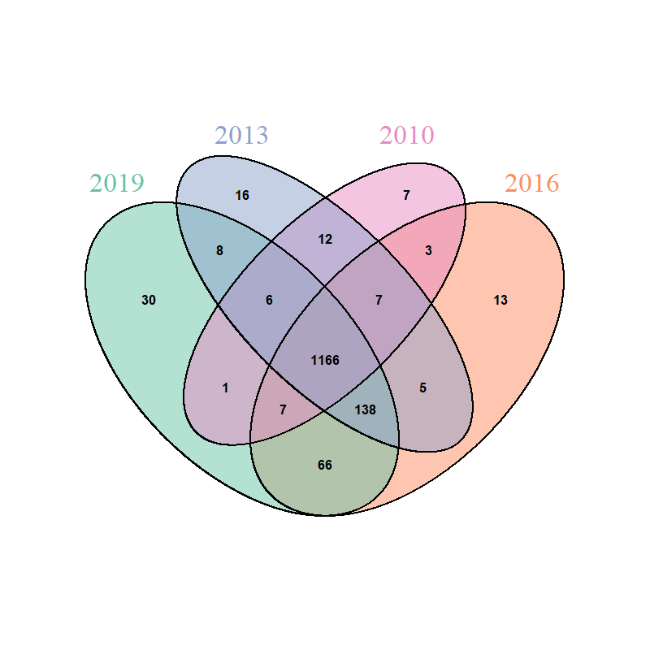

#### Top Countries

|  |  |  |  |  |  |
| --- | --- | --- | --- | --- | --- |
| **Code** | **Country** | **2010** | **2013** | **2016** | **2019** |
| AT | Austria | 23 | 30 | 32 | 32 |
| AU | Australia | 7 | 9 | 9 | 14 |
| BE | Belgium | 10 | 8 | 12 | 12 |
| BM | Bermuda | 15 | 17 | 14 | 13 |
| BR | Brazil | 38 | 40 | 35 | 38 |
| CA | Canada | 18 | 16 | 13 | 22 |
| CH | Switzerland | 6 | 6 | 5 | 5 |
| CN | China | 39 | 21 | 21 | 11 |
| DE | Germany | 3 | 4 | 2 | 2 |
| DK | Denmark | 9 | 7 | 16 | 10 |
| ES | Spain | 8 | 10 | 8 | 7 |
| FI | Finland | 35 | 29 | 24 | 46 |
| FR | France | 1 | 2 | 3 | 3 |
| GB | United Kingdom | 2 | 1 | 1 | 1 |
| HK | Hong Kong | 16 | 32 | 27 | 21 |
| IE | Ireland | 31 | 31 | 30 | 19 |
| IN | India | 22 | 23 | 25 | 17 |
| IT | Italy | 12 | 11 | 11 | 9 |
| JP | Japan | 14 | 12 | 6 | 8 |
| KY | Cayman Islands | 21 | 13 | 15 | 23 |
| LU | Luxembourg | 11 | 14 | 10 | 15 |
| MU | Mauritius | 25 | 26 | 20 | 28 |
| MX | Mexico | 47 | 42 | 42 | 35 |
| MY | Malaysia | 29 | 36 | 29 | 30 |
| NL | Netherlands | 5 | 5 | 7 | 6 |
| NO | Norway | 24 | 22 | 28 | 29 |
| PA | Panama | 43 | 47 | 39 | 27 |
| PT | Portugal | 13 | 34 | 34 | 43 |
| RU | Russian Federation | 28 | 28 | 26 | 31 |
| SA | Saudi Arabia | 32 | 35 | 41 | 50 |
| SE | Sweden | 20 | 18 | 17 | 24 |
| SG | Singapore | 19 | 20 | 22 | 18 |
| TR | Turkey | 30 | 38 | 33 | 36 |
| US | United States | 4 | 3 | 4 | 4 |
| VG | Virgin Islands, British | 17 | 24 | 18 | 16 |
| ZA | South Africa | 26 | 25 | 23 | 25 |

#### Continental/Regional

|  |  |  |  |  |
| --- | --- | --- | --- | --- |
| **Continent/Region** | **2010** | **2013** | **2016** | **2019** |
| **Africa** | **1%** | **2%** | **3%** | **2%** |
| **Asia** | **12%** | **16%** | **20%** | **20%** |
| **Eastern Asia** | **7%** | **8%** | **8%** | **10%** |
| **Middle East** | **1%** | **4%** | **5%** | **5%** |
| **Southeast Asia** | **3%** | **2%** | **3%** | **2%** |
| **Southern and Central Asia** | **1%** | **2%** | **4%** | **3%** |
| **Europe** | **51%** | **45%** | **43%** | **40%** |
| **British Islands** | **5%** | **5%** | **3%** | **3%** |
| **Eastern Europe** | **8%** | **4%** | **4%** | **3%** |
| **Nordic Countries** | **4%** | **4%** | **4%** | **5%** |
| **Southern Europe** | **8%** | **8%** | **10%** | **7%** |
| **Western Europe** | **26%** | **24%** | **22%** | **22%** |
| **North America** | **28%** | **28%** | **24%** | **25%** |
| **Caribbean** | **2%** | **2%** | **2%** | **2%** |
| **Central America** | **2%** | **2%** | **1%** | **2%** |
| **North America** | **24%** | **24%** | **21%** | **21%** |
| **Oceania** | **2%** | **3%** | **3%** | **5%** |
| **South America** | **6%** | **6%** | **7%** | **8%** |
| **Grand Total** | **100%** | **100%** | **100%** | **100%** |



1. Average degree is given as $Avg. Degree=2×\frac{\left|E\right|}{\left|V\right|}$. This measure tells how many edges are in a graph compared to vertices. [↑](#footnote-ref-1)
2. APL is the arithmetic mean of distance of all pairs of nodes, i.e. $APL=\frac{\sum_{u,v;u≠v}{d_{u,v}}}{\left|V\right|\left(\left|V\right|-1\right)}$. Low APL indicates that the graph is small-world, given it has high clustering coefficient. [↑](#footnote-ref-2)
3. . Determines how strong the most strongly connected vertex in a graph is. [↑](#footnote-ref-3)
4. The ratio between number of edges to number of possible edges, given as: $Density=\frac{\left|E\right|}{\left|V\right|(\left|V\right|-1)}$. Density=1 denotes that the graph is a clique. [↑](#footnote-ref-4)
5. Transitivity is the global clustering coefficient of a graph. Where clustering coefficient of a vertex is its tendency to form a cluster with other nodes. It’s given as: $T=\frac{\sum_{u∈V}{C_{u}}}{\left|V\right|};C_{u}=\frac{2×|\{e_{vw}|v,w∈N_{u},e_{vw}∈E\}|}{k_{u}(k_{u}-1)}$. Meaning the sum of edges between the neighbours $N_{u}$ of node $u$ divided by the number of possible edges in the neighbourhood of . [↑](#footnote-ref-5)
6. Person correlation between a pair of vertices. A graph is highly assortative if its hubs are interconnected. [↑](#footnote-ref-6)
7. Power law coefficient measures the skewness of the slope of the log-log plot of degree distribution in a graph, given that the degree distribution of the graph follows the power law. [↑](#footnote-ref-7)